Experiment -1
NAME:G.CHAKRADHAR
REGNO:192311439
Title
Design and Development of a Client-Side Library Management System Using HTML and CSS
Aim
To design and develop a responsive Library Management System using HTML5 and CSS3 that provides a user-friendly interface for managing library-related pages such as Home, Login, Registration, Book Catalog, Admin Dashboard, Student Profile, Borrow History, Fine Details, Study Materials, and Contact Information. The website is developed as a client-side application without using JavaScript, databases, or server-side programming.

Algorithm:
- Create the project folder and HTML pages.
- Link all pages using a common navigation bar.
- Create a single external style.css file.
- Design the Home, Login, Register, Books, Admin, Profile, Borrow, Fine, Materials, and Contact pages.
- Apply a consistent layout, colors, fonts, and responsive design.
- Add CSS-only animations, hover effects, and smooth scrolling.
- Test all page links, layouts, and responsiveness.

Website link: https://chakri142.github.io/experment-1-slot-c/

Website images :
1.HOME PAGE:

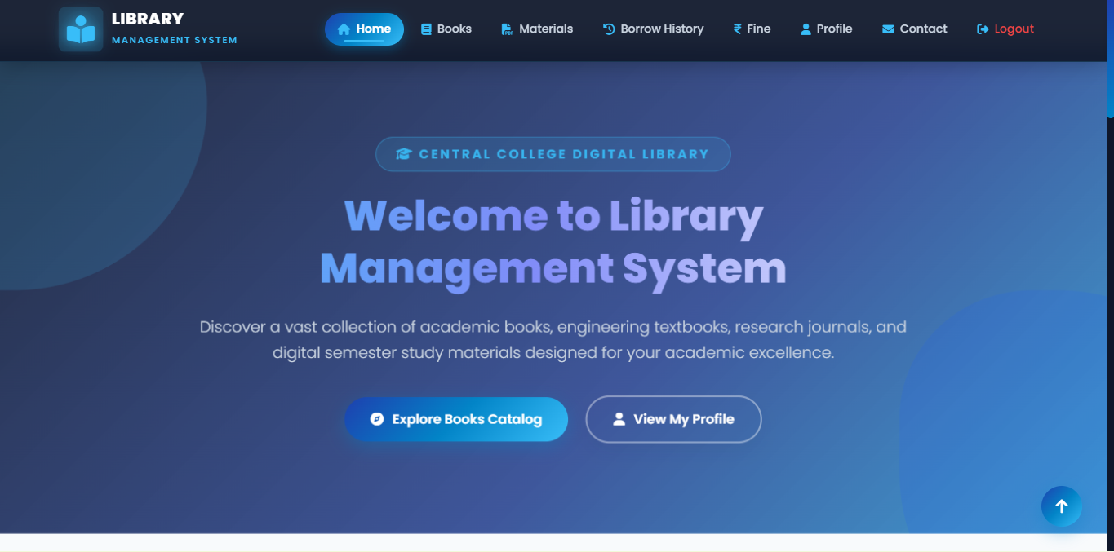

2.REGISTER PAGE :
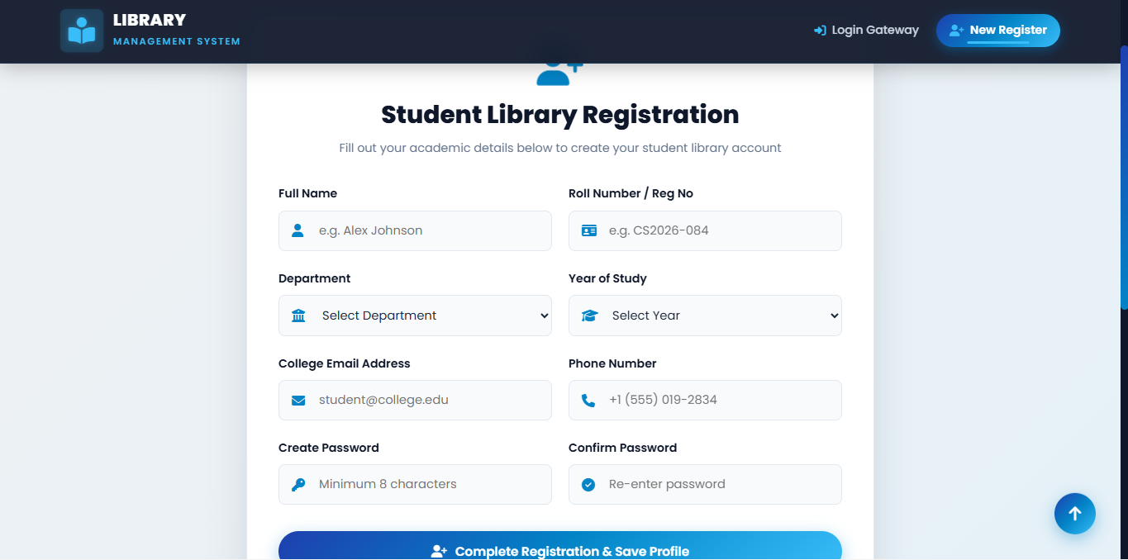

3.LOGIN PAGE :
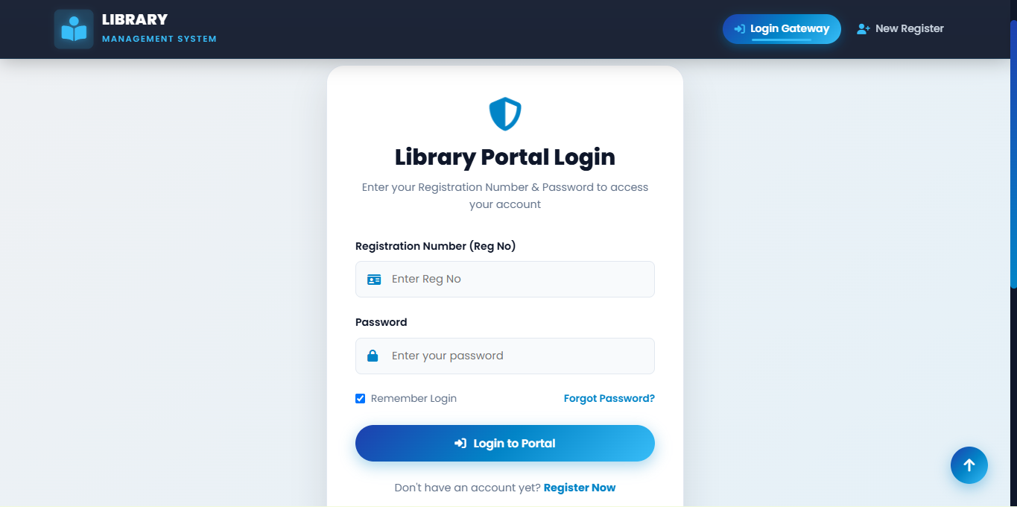

4.ADMIN LOGIN PAGE

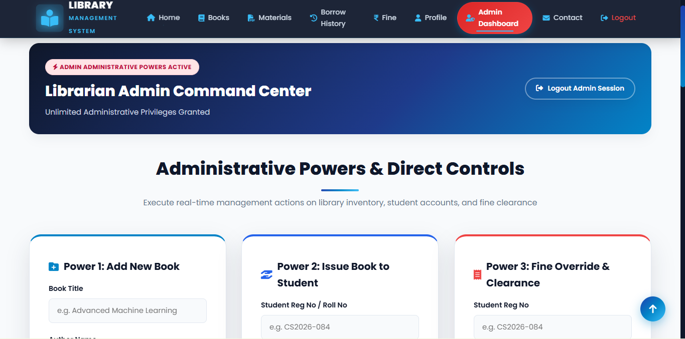

5.BOOKS PAGE :

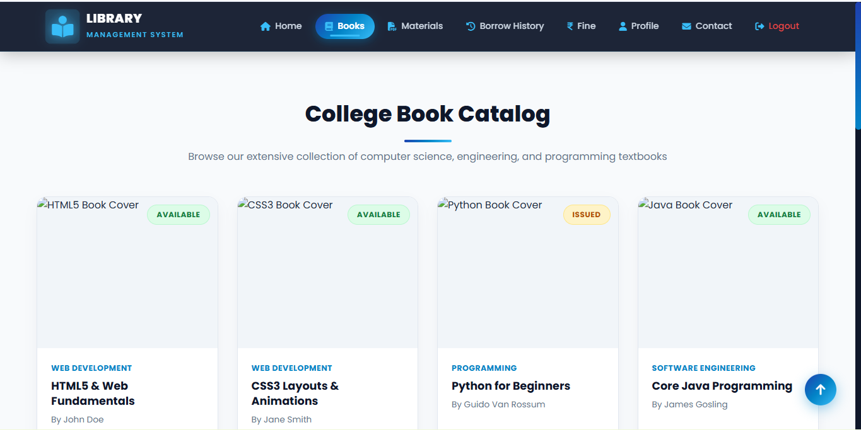

6.MATERIAL PAGE

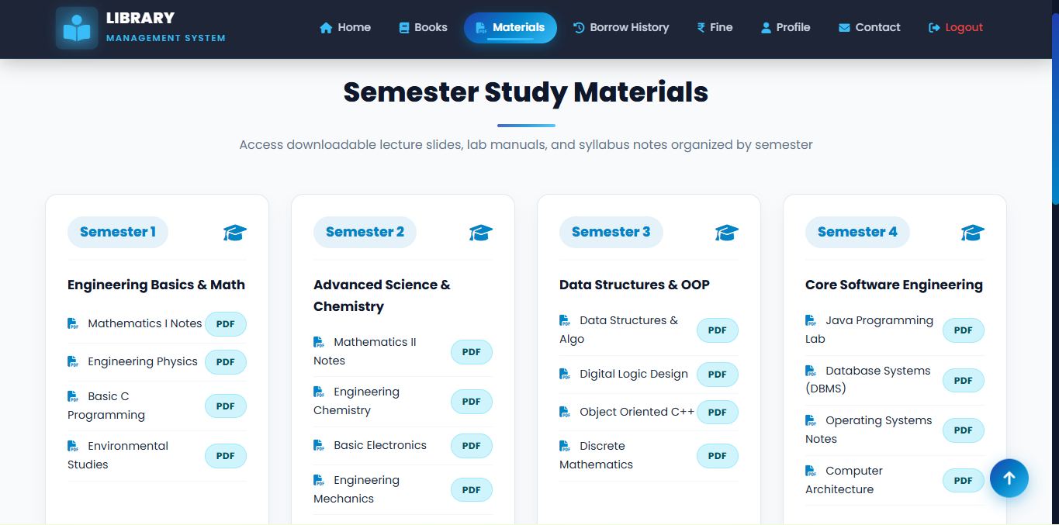

7. BORROW HISTORY PAGE
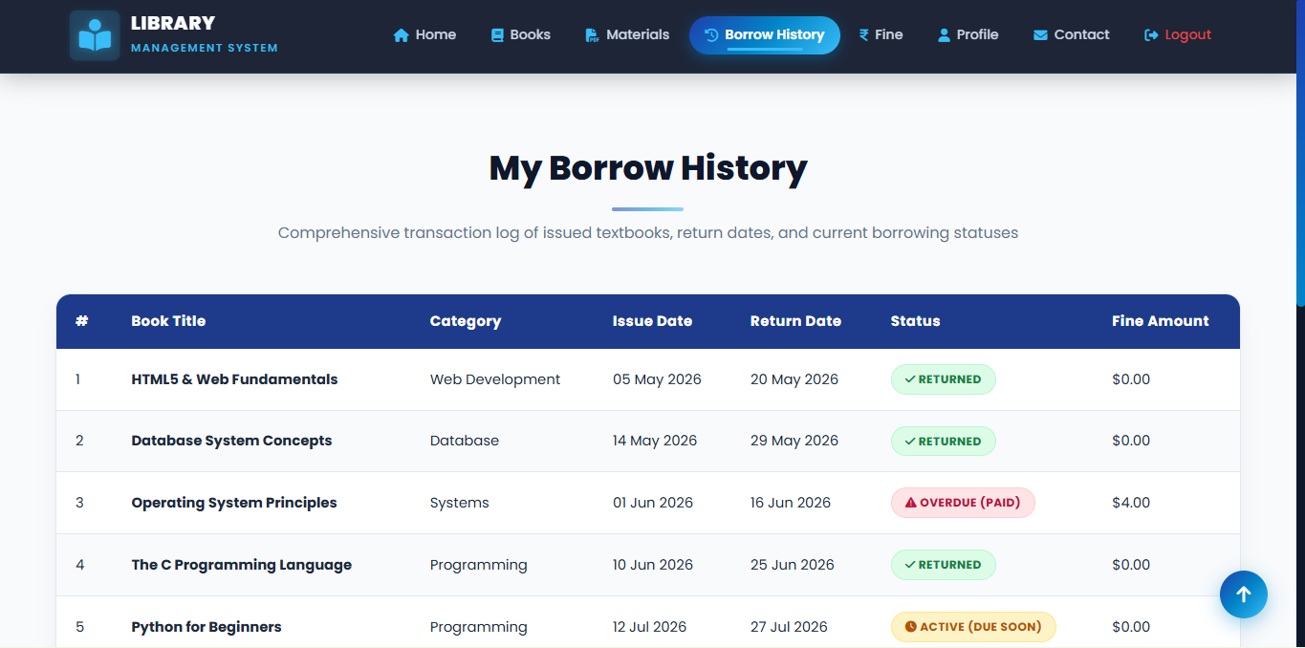

8.FINE PAGE

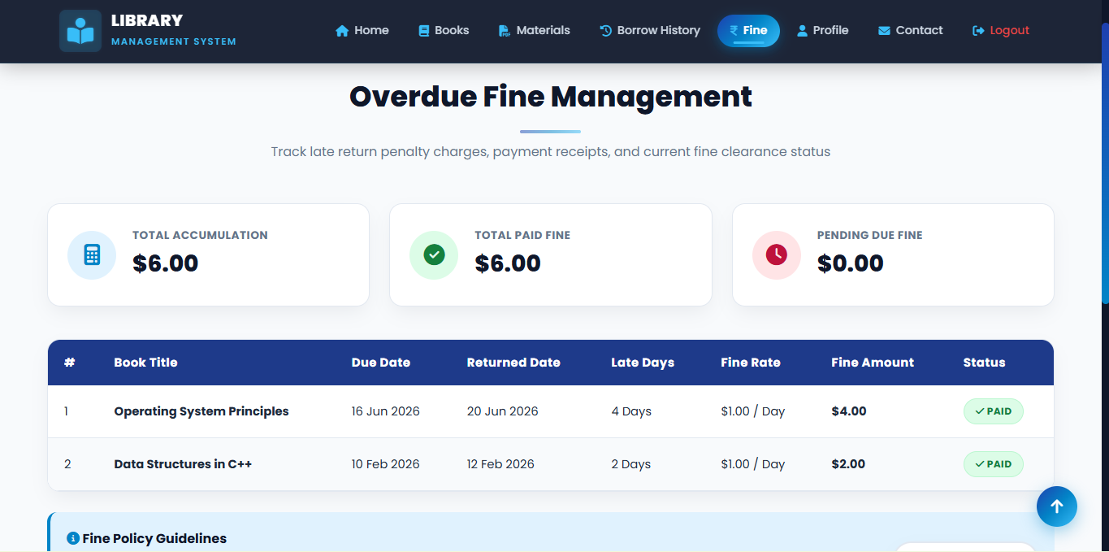

9.CONTACT PAGE

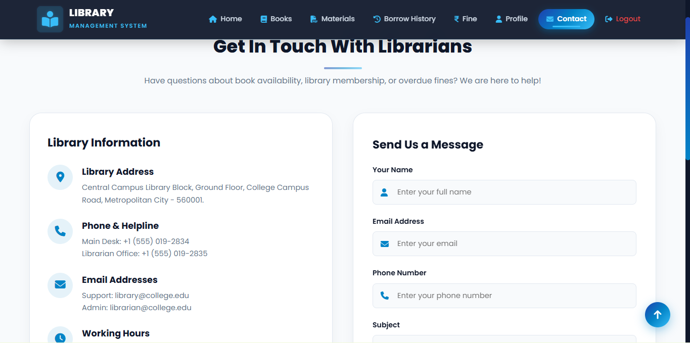

Result
A responsive Library Management System website was successfully developed using HTML5 and CSS3, with multiple linked pages, a modern user interface, and CSS-only animations as a client-side web application.

